The Protective Turtle Ecology Center for Training, Outreach, and Research, Inc.
(ProTECTOR Inc.)
Intern/Volunteer Application
2020 - 2023
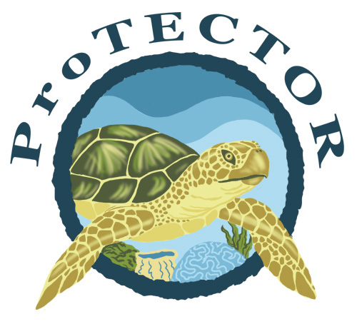
R e s e a r c h a n d C o n s e r v a t i o n
f o r t h e
S e a T u r t l e s o f H o n d u r a s a n d T h a i l a n d
Volunteer/Group/Intern Application and Information Form
The following information helps us to get a better idea of your interests and background. Thank you for your interest in ProTECTOR Inc. This form must be filled in and returned to the ProTECTOR Inc.Volunteer Coordinator no later than 90 days prior to your planned arrival in Honduras or Thailand. Please respond to the questions in both Part I and II of this information sheet and return to us at:

E-mail: sdunbar@llu.edu
Phone: (909) 558-1000, 48903
Fax: (909) 558-0259

Part I: Personal Information

Name:

Date of Birth:

Home Address:

Telephone Number:

Fax Number:

E-mail Address:

Languages:

Person to contact in case of emergency
Name:
Relationship:
Address:
Telephone Number:

Part II: Project Interests and Background

What are the dates in which you would like to participate in a project (the days you will actually spend in the project and not your travel dates)?

In order for us to pick you up at the airport, we will need your flight details. You can include your flight details now or send them later.

How did you hear about ProTECTOR Inc. and the ProTECTOR Inc. Volunteer Program? This is very important to us!

Do you have any knowledge about Sea Turtles and the issues that threaten them?

Please give us an idea of what you have been doing for the last 2 years. In addition to this summary, please be sure to mention any other experience that you think might be relevant to the project. Please do not attach a resume instead of this summary.

If you plan to Intern with ProTECTOR Inc., please provide a potential project idea that you might like to pursue for your research. You may not be able to do what you are imagining (time, funding, logistical constraints), but it will give us an idea of potential projects we could work with you on developing.

